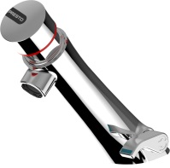
PRESTO NEO – 68403
Deck-mounted mixer self-closing tap with lateral mixer lever. As Presto NEO® ref. 68403 or technically equivalent.
Equipped against corrosion and lime scale with a self-cleaning needle and ruby mechanism, preset at 3 l/mn (inner adjustment). 15 sec timed-flow. Anti-rotation push button with laser marking. With temperature limiter, PEX hoses, straight stop valves and filters. With S® antiblocking system to prevent blocking in continuous flow.
Or
Deck-mounted mixer self-closing tap with lateral mixer lever. As Presto NEO® ref. 68403 or technically equivalent. Including :
- Self-cleaning needle and ruby mechanism
- Preset at 3 l/mn (inner adjustment)
- Lateral mixer lever
- Anti-rotation push button with laser marking.
- 15 sec. timed-flow
- With temperature limiter
- PEX hoses, straight stop valves and filters
- With S® antiblocking system to prevent blocking in continuous flow

