PRESTO NEO® DUO S® – 68097
Wall-mounted self-closing mixer tap, with an ergonomic soft touch lever to control water flow, 3/8". As PRESTO NEO® DUO S® antiblocking system ref.68097 or technically equivalent. Equipped against corrosion and lime scale with a self-cleaning needle and ruby mechanism, preset at 3 l/mn. Dual timed-flow: 7 sec. (lever upwards) and 11 sec. (lever downwards). Flow rate and flow time could be changed by internal device only. With S® antiblocking system to prevent blocking in continuous flow.
Or
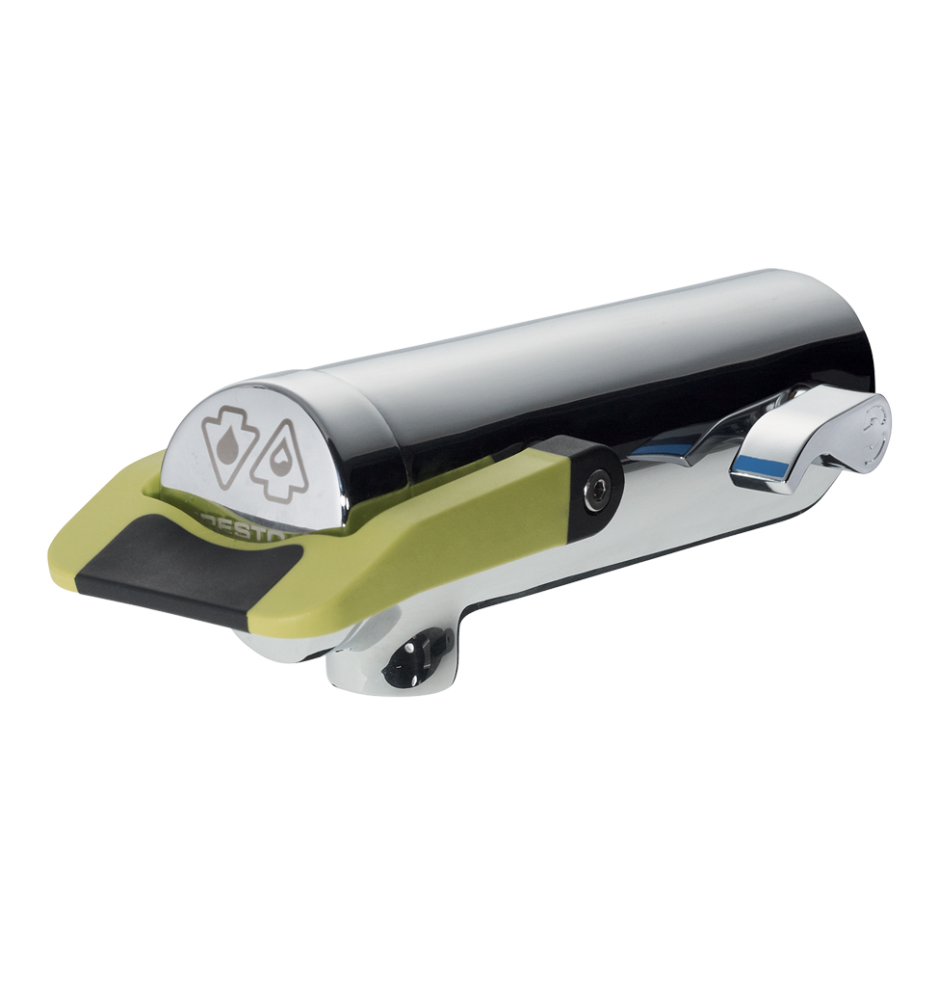
Wall-mounted self-closing mixer tap, with an ergonomic soft touch lever to control water flow, 3/8". As PRESTO NEO® DUO S® antiblocking system ref. 68097 or technically equivalent. Including:
- A self-cleaning needle and ruby mechanism
- Preset at 3 l/mn flow rate (inner adjustment)
- Dual timed-flow: 7 sec. (lever upwards) and 11 sec. (lever downwards)
- Flow rate and flow time could be changed by internal device only
- Soft touch
- With S® antiblocking system to prevent blocking in continuous flow

.

