PRESTO NEO® DUO S® – 68096
Wall-mounted self-closing mixer tap, with an ergonomic soft touch lever to control water flow, 3/8". As PRESTO NEO® DUO S® antiblocking system ref.68096 or technically equivalent. Equipped against corrosion and lime scale with a self-cleaning needle and ruby mechanism, preset at 3 l/mn. 15 sec timed-flow (lever upwards or downwards). Flow rate and flow time could be changed by internal device only. With S® antiblocking system to prevent blocking in continuous flow.
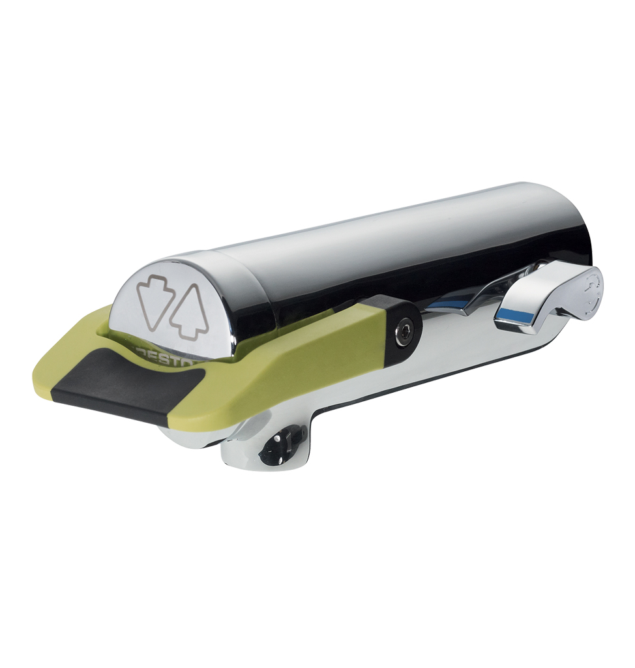
Or
Wall-mounted self-closing mixer tap, with an ergonomic soft touch lever to control water flow, 3/8". As PRESTO NEO® DUO S® antiblocking system ref. 68096 or technically equivalent. Including:
- A self-cleaning needle and ruby mechanism
- Preset at 3 l/mn flow rate (inner adjustment)
- 15 sec timed-flow (lever upwards or downwards)
- Flow rate and flow time could be changed by internal device only
- Soft touch
- With S® antiblocking system to prevent blocking in continuous flow

.

