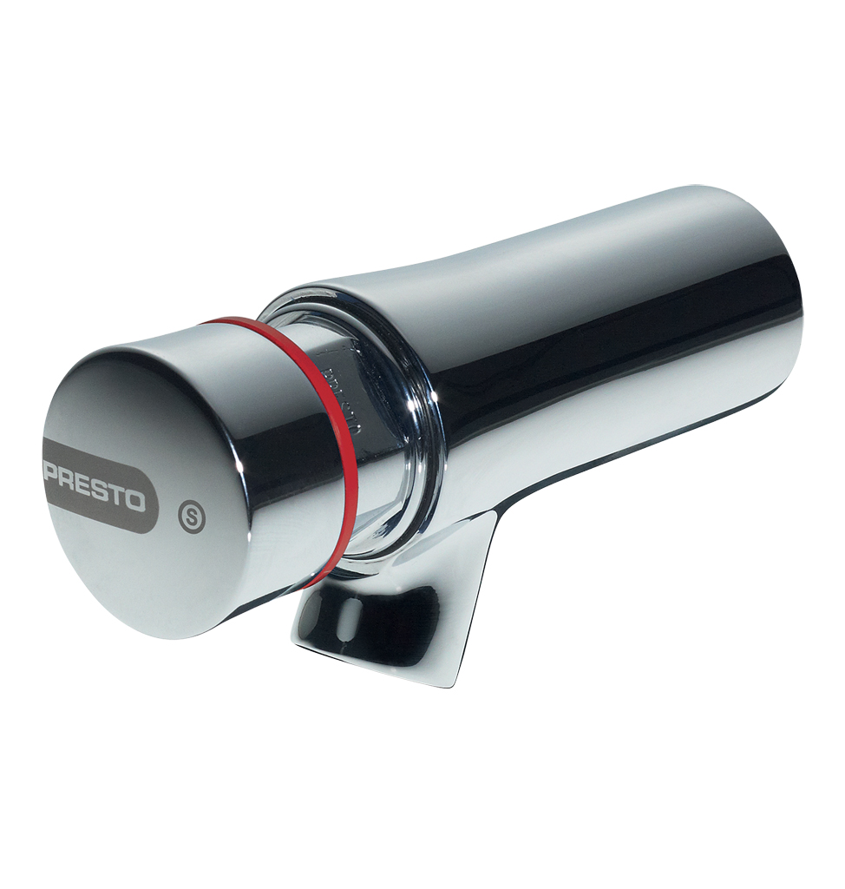
PRESTO NEO® S® – 66300
Single wall-mounted self-closing tap, 1/2", hot water, 65mm projection. As Presto NEO® S® antiblocking system ref. 66300 or technically equivalent. Equipped against corrosion and lime scale with a self-cleaning needle and ruby mechanism, preset at 3 l/mn (inner adjustment). 15 sec timed-flow. Anti-rotation push button with laser marking. With S® antiblocking system to prevent blocking in continuous flow
Or
Single wall-mounted self-closing tap, 1/2", hot water, 65mm projection. As Presto NEO® S® antiblocking system ref. 66300 or technically equivalent. Including:
- Self-cleaning needle and ruby mechanism
- Preset at 3 l/mn (inner adjustment)
- Anti-rotation push button with laser marking.
- 15 sec. timed-flow
- With S® antiblocking system to prevent blocking in continuous flow

.

