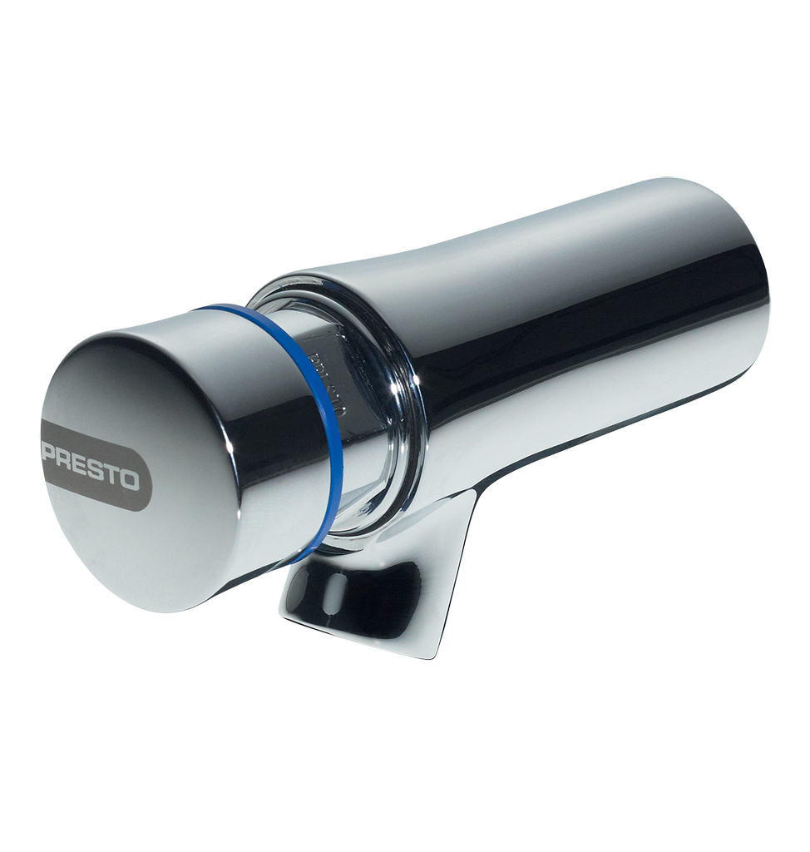
PRESTO NEO® – 66000
Single wall-mounted self-closing tap, 1/2", cold water, 65mm projection. As Presto NEO® ref. 66000 or technically equivalent. Equipped against corrosion and lime scale with a self-cleaning needle and ruby mechanism, preset at 3 l/mn (inner adjustment). 15 sec timed-flow. Anti-rotation push button with laser marking. NF compliant.
Or
Single wall-mounted self-closing tap, 1/2", cold water, 65mm projection. As Presto NEO® ref. 66000 or technically equivalent. NF compliant. Including:
- Self-cleaning needle and ruby mechanism
- Preset at 3 l/mn (inner adjustment)
- Anti-rotation push button with laser marking.
- 15 sec. timed-flow

.

