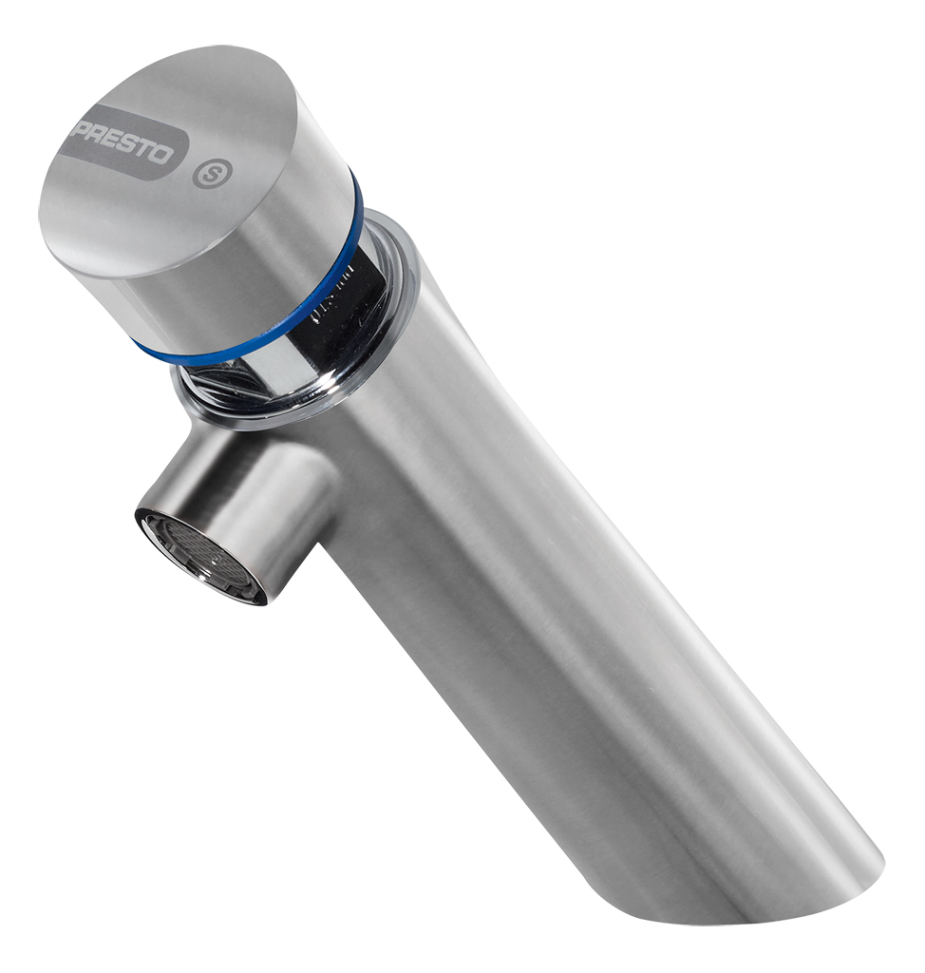
PRESTO NEO® S® – 65210
Single deck-mounted self-closing tap, stainless steel body, 1/2", cold water. As Presto NEO® S® antiblocking system ref. 65210 or technically equivalent. Equipped against corrosion and lime scale with a self-cleaning needle and ruby mechanism, preset at 3 l/mn (inner adjustment). 7 sec timed-flow. Anti-rotation push button with laser marking. With S® antiblocking system to prevent blocking in continuous flow
Or
Single deck-mounted self-closing tap, stainless steel body, 1/2", cold water. As Presto NEO® S® antiblocking system ref. 65210 or technically equivalent. Including:
- Self-cleaning needle and ruby mechanism
- Preset at 3 l/mn (inner adjustment)
- Anti-rotation push button with laser marking.
- 7 sec. timed-flow
- With S® antiblocking system to prevent blocking in continuous flow

.

