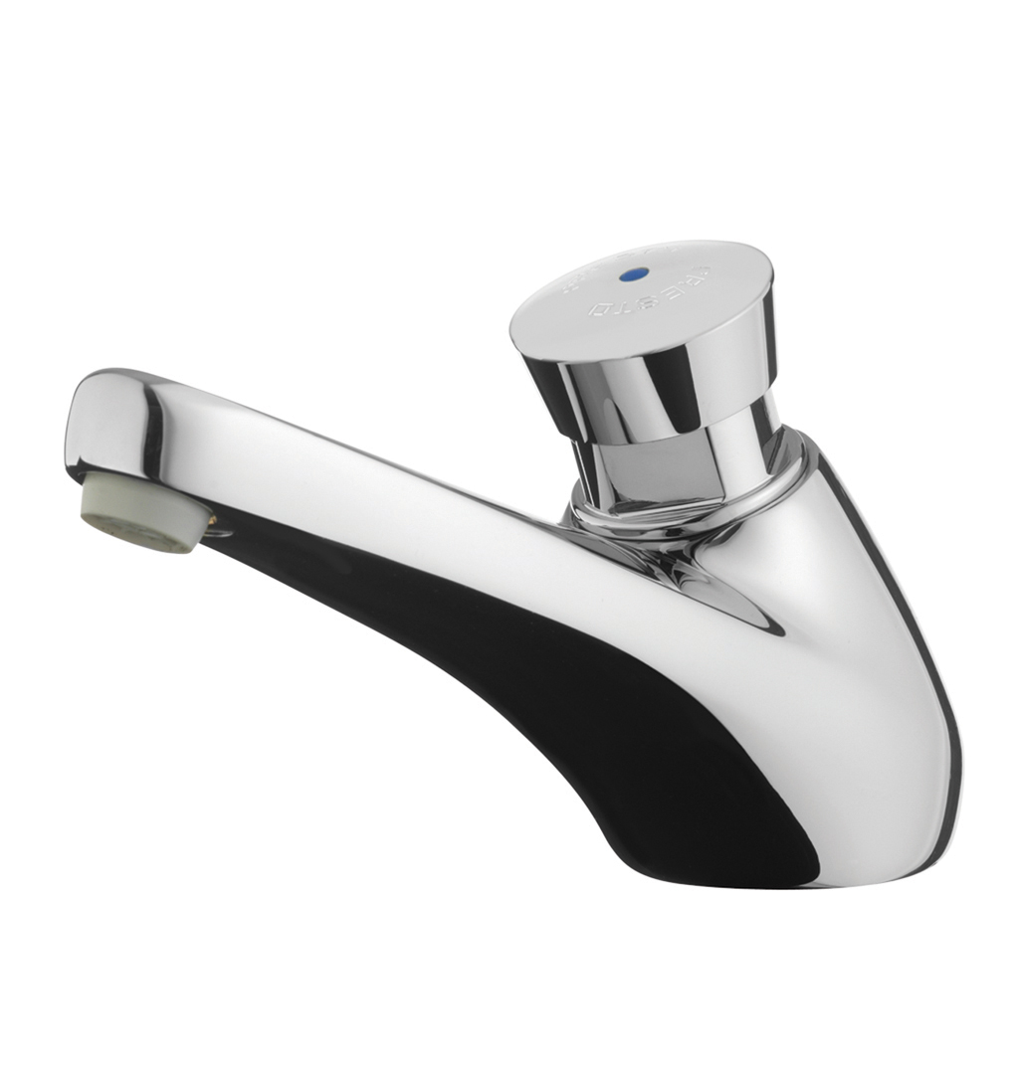
605 –64944
Single deck mounted self-closing tap with anti-rotation button, cold water.
Type PRESTO 605 ref 64944 or technically equivalent.
Equipped against corrosion and lime scale with a self-cleaning needle and ruby mechanism. Preset at 3L/min (flow rate could be change by internal device). Flow time of 7seconds.
NF certified product with 10-year warranty – ISO 90001 manufacturer

