PRESTO NEO® DUO – 64765
Single wall-mounted self-closing tap, with an ergonomic soft touch lever to control water flow, 1/2", hot or cold water. As PRESTO NEO® DUO ref.64765 or technically equivalent. Equipped against corrosion and lime scale with a self-cleaning needle and ruby mechanism, 1.9 l/mn with flow regulator. 15 sec timed-flow (lever upwards or downwards). Flow rate and flow time could be changed by internal device only. NF compliant.
Or
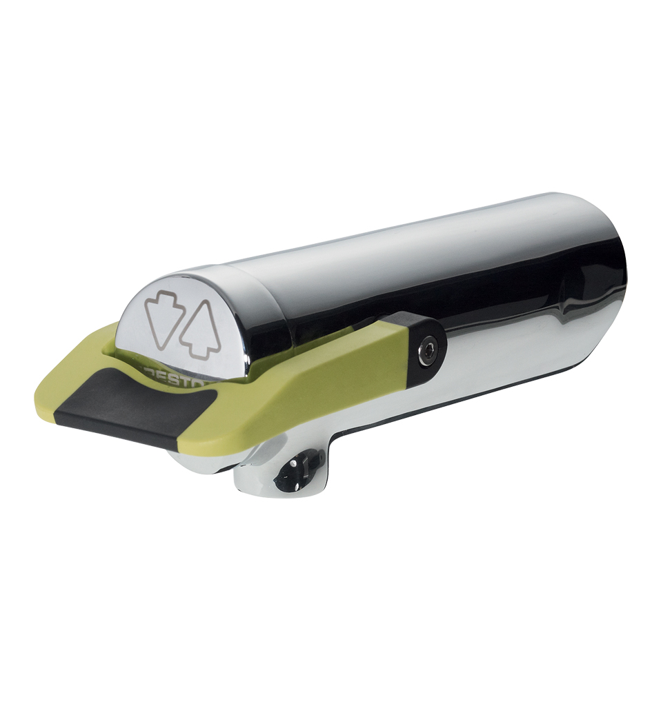
Single wall-mounted self-closing tap, with an ergonomic soft touch lever to control water flow, 1/2", hot or cold water. NF compliant. As PRESTO NEO® DUO ref.64765 or technically equivalent. Including:
- A self-cleaning needle and ruby mechanism
- 1.9 l/mn with flow regulator
- 15 sec timed-flow (lever upwards or downwards)
- Flow rate and flow time could be changed by internal device only
- Soft touch

.

