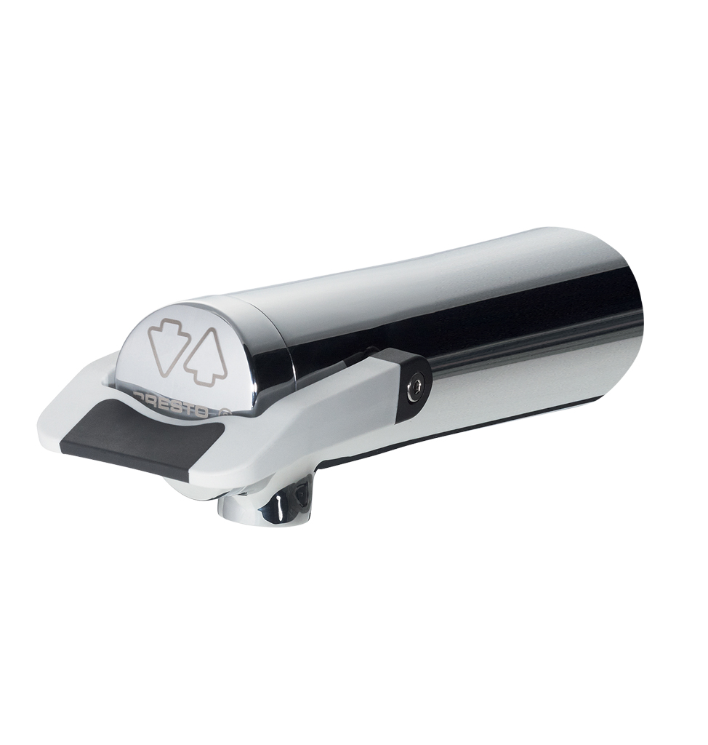
PRESTO NEO® DUO – 64711
Single wall-mounted self-closing tap, with an ergonomic soft touch lever to control water flow, 1/2", hot or cold water. As PRESTO NEO® DUO ref.64711 or technically equivalent. Equipped against corrosion and lime scale with a self-cleaning needle and ruby mechanism, preset at 3 l/mn. 7 sec timed-flow (lever upwards or downwards). Flow rate and flow time could be changed by internal device only. NF compliant.
Or
Single wall-mounted self-closing tap, with an ergonomic soft touch lever to control water flow, 1/2", hot or cold water. NF compliant. As PRESTO NEO® DUO ref.64711 or technically equivalent. Including:
- A self-cleaning needle and ruby mechanism
- Preset at 3 l/mn flow rate (inner adjustment)
- 7 sec timed-flow (lever upwards or downwards)
- Flow rate and flow time could be changed by internal device only
- Soft touch

.

