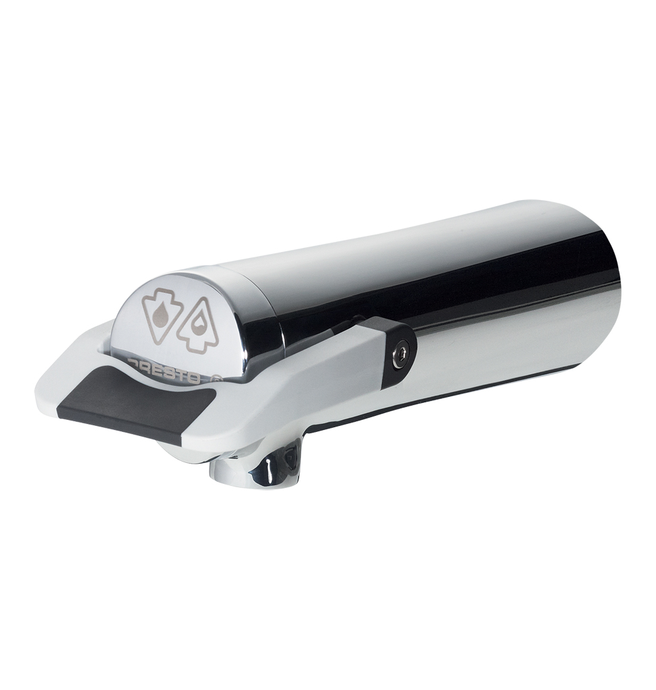
PRESTO NEO® DUO S® – 64710
Single wall-mounted self-closing tap, with an ergonomic soft touch lever to control water flow, 1/2", hot or cold water. As PRESTO NEO® DUO S® antiblocking system ref.64710 or technically equivalent. Equipped against corrosion and lime scale with a self-cleaning needle and ruby mechanism, 1.9 l/mn with flow regulator. Dual timed-flow: 7 sec. (lever upwards) and 11 sec. (lever downwards). Flow rate and flow time could be changed by internal device only. With S® antiblocking system to prevent blocking in continuous flow.
Or
Single wall-mounted self-closing tap, with an ergonomic soft touch lever to control water flow, 1/2", hot or cold water. As PRESTO NEO® DUO S® antiblocking system ref.64710 or technically equivalent. Including:
- A self-cleaning needle and ruby mechanism
- 1.9 l/mn with flow regulator
- Dual timed-flow: 7 sec. (lever upwards) and 11 sec. (lever downwards)
- Flow rate and flow time could be changed by internal device only
- Soft touch
- With S® antiblocking system to prevent blocking in continuous flow

.

