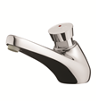
605 S - 64632
Single deck-mounted self-closing tap, hot water
Inlet 1/2 ''
Flow rate 6L/mn at 417 kPa
Flow duration of 15 sec
self cleaning mechanism,
Internal components in anti-corrosion and anti-liming materials,
Easy adjustment of the flow time,
Anti-rotation push-button.
“S” security system to prevent continuous flow.

