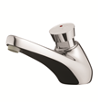
TIME FLOW TAP
Inlet 1/2 ''
Flow rate 6L/mn at 417 kPa
Flow duration of 7 sec
self cleaning mechanism,
internal components in anti-corrosion and anti-liming materials,
easy adjustment of the flow time,
anti-rotating push-button.
“S” security system to prevent continuous flow.

