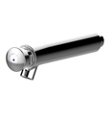
TIME FLOW TAP
Wall mounted push button tap for cold water, with automatic time delayed shut off 15 sec +/- 5 sec
Inlet 1/2 ''
Flow rate 1.9L/mn at 417 kPa
self –cleaning mechanism
internal components in anti corrosion and anti-liming materials
“S” security system to prevent continuous flow.
with blue dot

