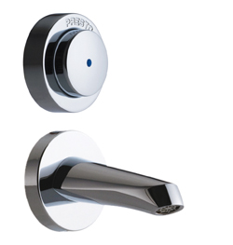
Complete kit for cross partition self closing tap with short spout.
For partitionfrom 200 to 300 mm
Self cleaning mechanism with synthetic ruby
non-rotating button
Check valve
S® antiblocking device to avoid continuous flow
Preset flowrate of 6 l / min (internally adjustable)
Inlets 1/2 "

