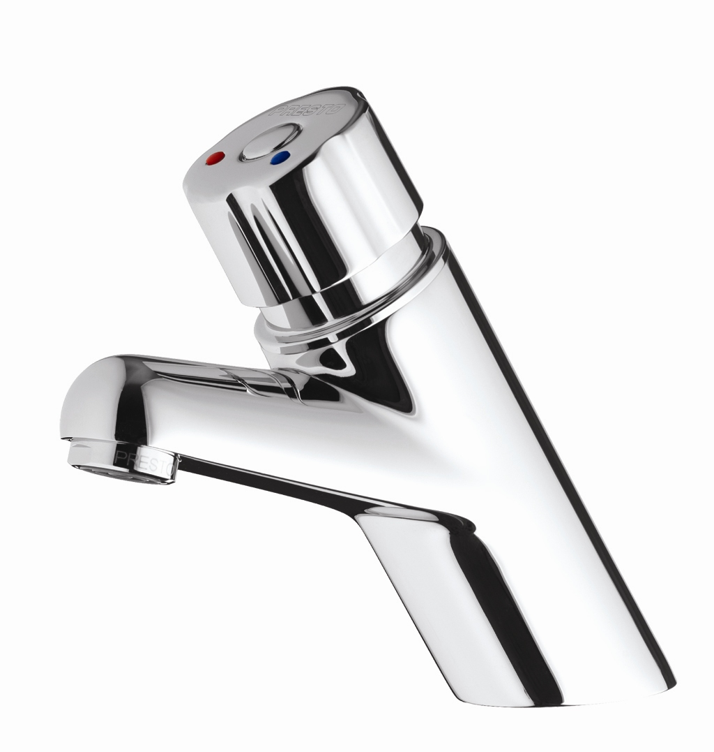
SELF CLOSING MIXER TAP
Basin-mounted single control mixer tap with automatic time delayed shut-off
Inlet 3/8 ''
Flow rate 1.9L/mn at 417 kPa
Flow duration of 15 sec
self cleaning mechanism,
internal parts made of anti-corrosion and anti-scaling materials,
with “S” security system to prevent continuous flow.
Chrome plated brass knob with flexible hoses and straight stop valve.

