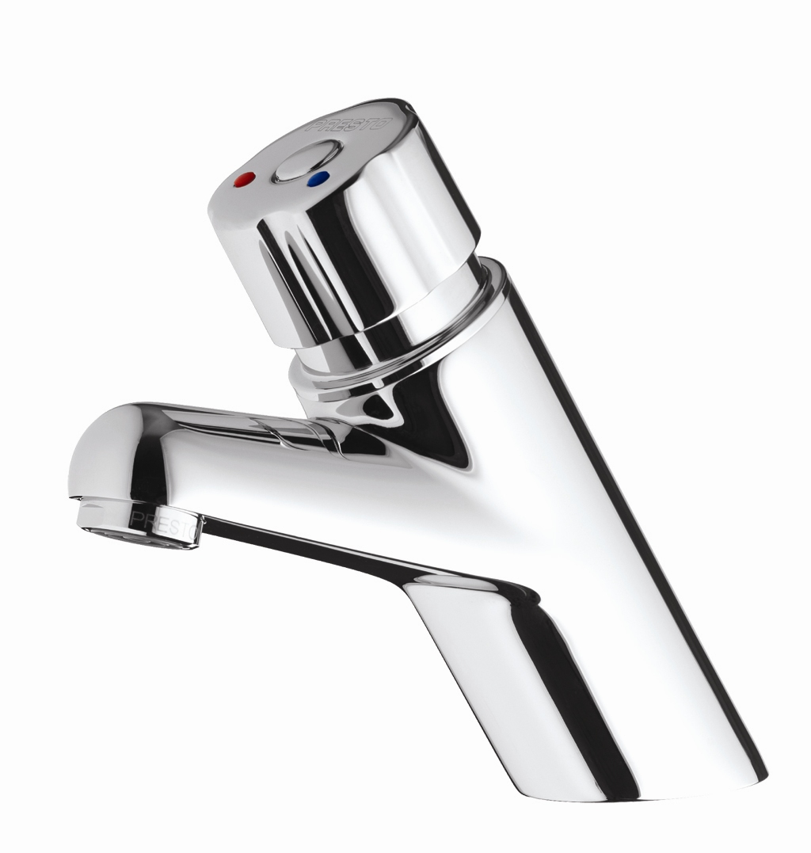
SELF CLOSING MIXER TAP
Basin-mounted single control mixer tap. Automatic time delayed shut-off, self cleaning mechanism,
internal parts made of anti-corrosion and anti-scaling materials,
with “S” security system to prevent continuous flow.
Chrome plated brass knob with flexible hoses and straight stop valve.

