DIRECT FLUSHVALVE
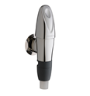
The self-closing PRESTO 1000 XL flush valve with built-in stop valve, activates the water flow by simply pressing the button on the cover. It delivers a constant volume of water. Recommended for sites with children, the elderly, etc.
Flush volume of 4L
Anti-water-hammering device
self cleaning mechanism with ruby,

